Coach Tillery’s Big Day

at 2015 ITU World Triathlon Grand Final Chicago
5th Place in the M40-44 AG, 2nd USA runner in that AG!!
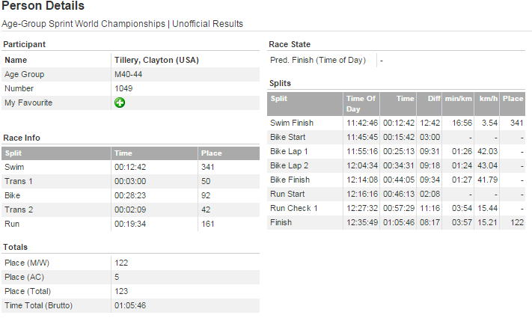
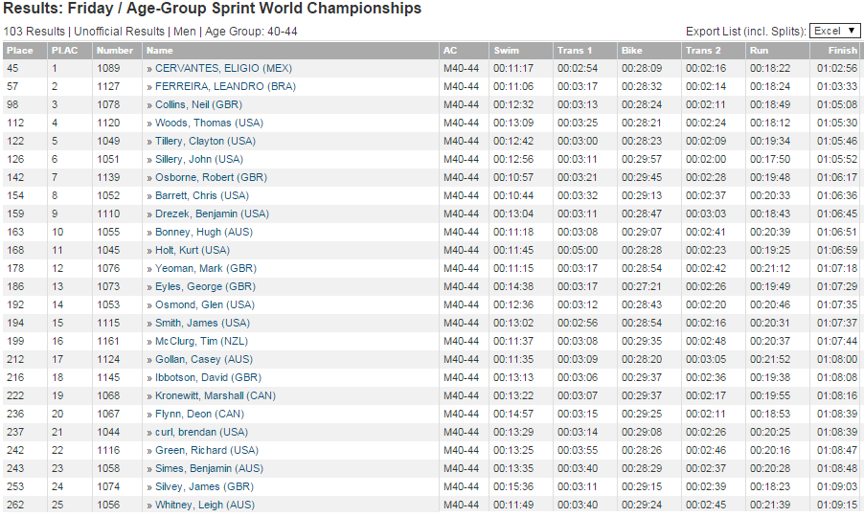
Screencast of Coach Tillery’s finish is here:
http://www.screencast.com/t/7nhLSQepN
(note… it’s a 90MB video!)
Some still pictures from the screencast:
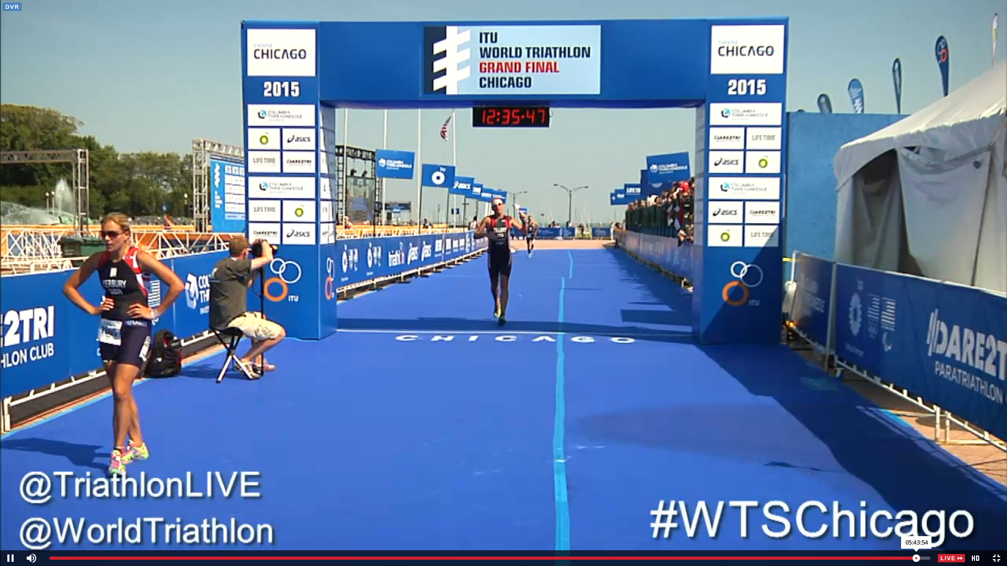
Good Finish… not sure about raising his arms while crossing the finish line, but he gets a pass given his finish!
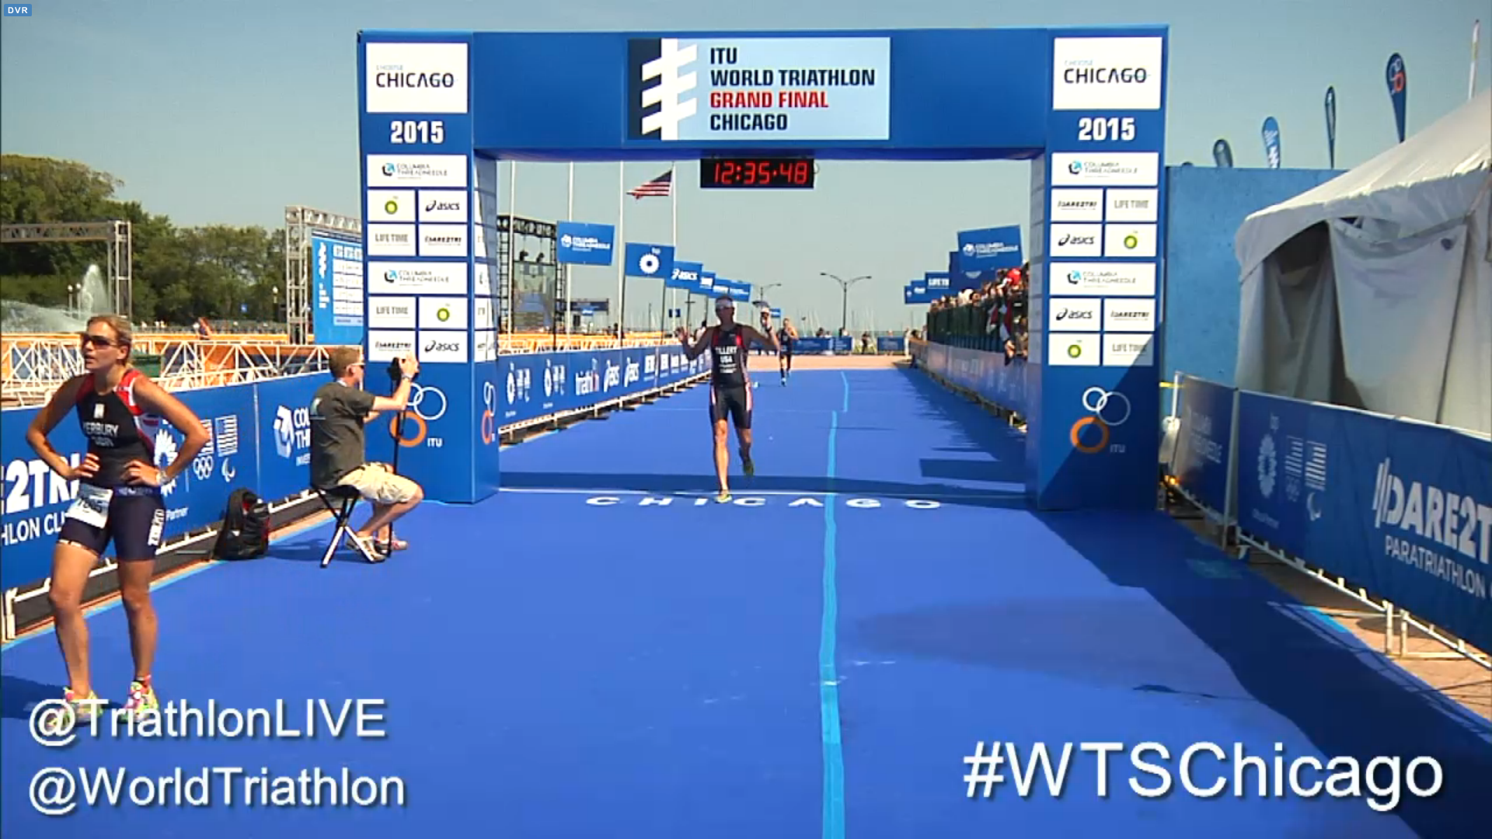

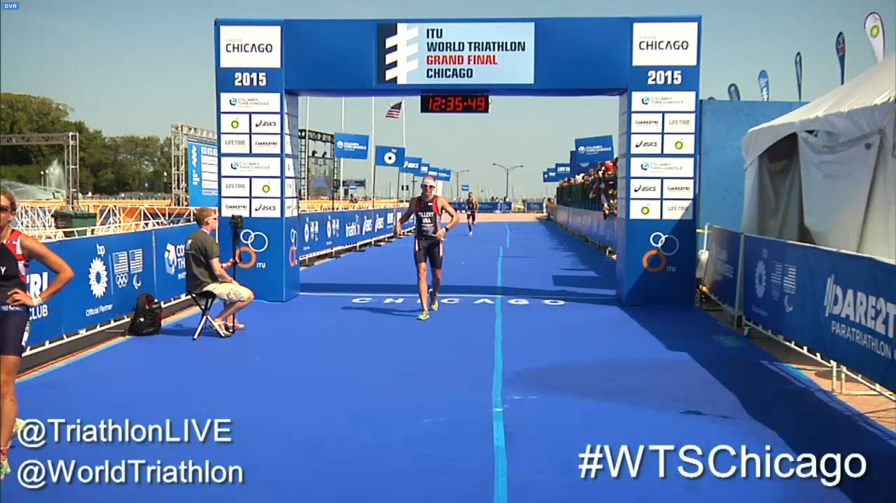
Love the Flag… Go USA!!!
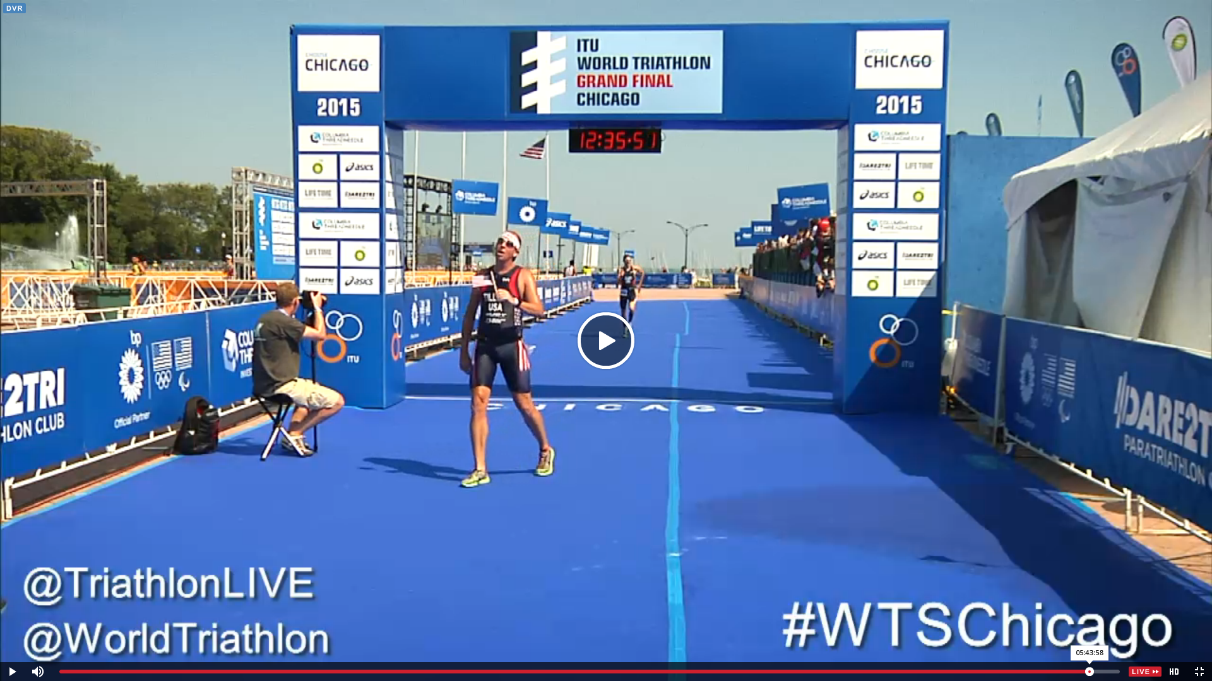

Someone looks tired… like they gave it their very best!
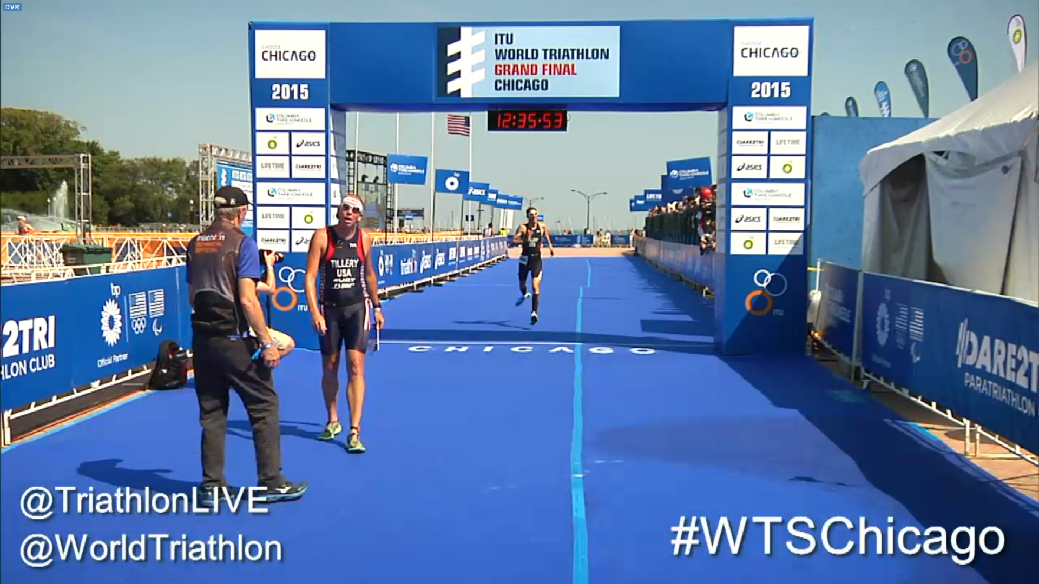

Good Sportsmanship Coach T!
